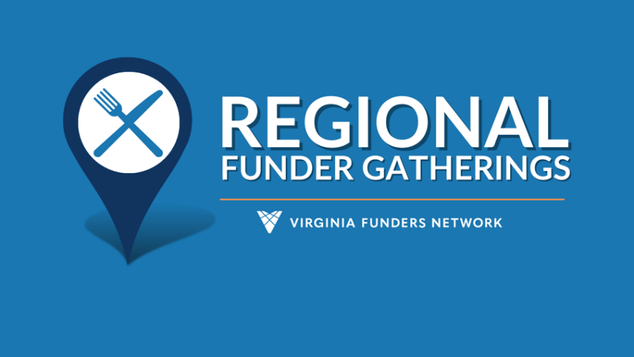

2024 Schedule

Region 7 Northern | Alexandria | July 24  Agenda Focus: Policy & Advocacy  Hosts:  - Heather Peeler/Brandi Yee, ACT for Alexandria  - Nicole Acosta, Community Foundation for Loudoun and Northern Fauquier Counties  - Renee Yancey/Sari Raskin, Community Foundation for Northern Virginia  - Courtney Rice/Rachel Lynch, Northern Virginia Health Foundation  Region 8 Shenandoah Valley | Waynesboro | August 13  Agenda Focus: Housing & presentation by Planning Commission  Hosts:  - Krystal Moyers, Augusta Health  - Dan Layman, Community Foundation for the Central Blue Ridge  - Mary Fant Donnan, The Alleghany Foundation  Region 9 Piedmont | Warrenton I August 21  Agenda Focus: GO VA +breakouts on journalism, economic mobility & civic engagement  Hosts:  - Stephanie Nerantzis, Claude Moore Charitable Foundation  - Nicole Acosta, Community Foundation for Loudoun and Northern Fauquier Counties  - Jane Bowling Wilson, Northern Piedmont Community Foundation  - Christy Connolly/Elizabeth Henrickson, PATH Foundation  Region 3 Southern | Danville | September 23  Agenda Focus: GO Virginia + BRIC presentations  Hosts:  - Clark Casteel, Danville Regional Foundation  - Kate Keller, The Harvest Foundation | Region 1 Southwest | Tazewell | September 25  Agenda Focus: Speaker on last year’s top 3 priorities  Hosts:  - Jeff Mansour, Thompson Charitable Foundation  - Sean McMurray, Wellspring Foundation for SW Virginia  Region 6 Upper Tidewater/Greater Fredericksburg | Warsaw | October 17  Agenda Focus: GO Virginia + group discussion from 2023 topics  Hosts:  - Sarah Reardon, Jessie Ball duPont Fund  - Lincoln Boykin, River Counties Community Foundation  - Leslie Franklin, Wiley Foundation  Region 5 Hampton Roads/Western Tidewater | Suffolk | November 20 @ 11-1:30pm  Agenda Focus: Nonprofit Capacity Building  Hosts (Bess & Patte)  - Battle Betts, Obici Healthcare Foundation  - Lorelei Marrow, Suffolk Foundation  - Whitney Saunders, Blocker Foundation  Region 4 Greater Richmond/Petersburg in partnership w/ CVFN | Richmond | December 3 @ 4-5:30pm  Agenda Focus: Social with VFN updates  Hosts:  - Carolyn Champion, Dominion Energy  - Greg Gallop, Community Foundation for a greater Richmond

